Burton Elementary School Bulletin
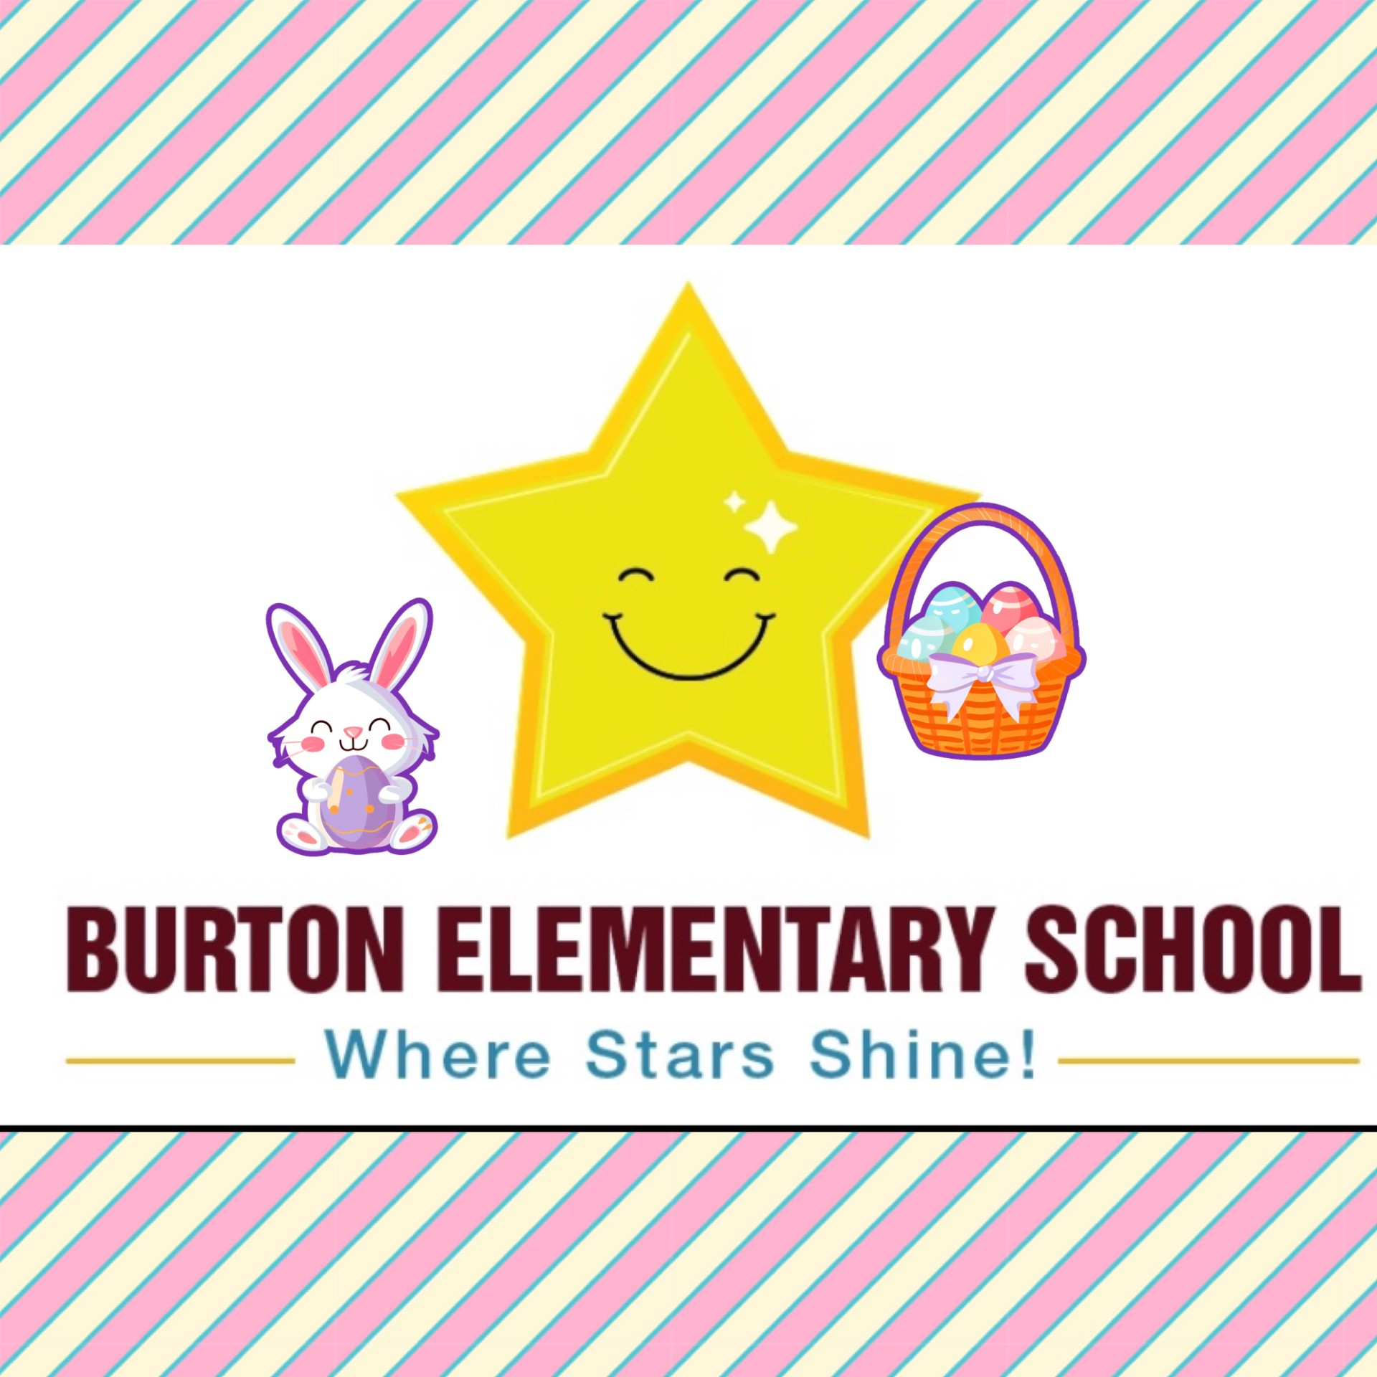
April 2025 Edition

Show Perseverance: STARS Focus for April This month students will be learning about showing perseverance. Perseverance is not giving up. It is persistence and tenacity, the effort required to do something and keep doing it till the end, even if it's hard.

Also, to work on our Growth Mindset, our April Mantra at school is “There’s a difference between not knowing and not knowing yet!”
Click on the link below to see a video: https://www.youtube.com/watch?v=XLeUvZvuvAs
Term 2 Reports Cards
Students will receive their report cards on April 7th. Parent teacher conferences will be held the afternoon and evening of April 10th and during the morning of April 11th Staff will be involved in professional learning sessions during the afternoon of April 11th. Students do not attend school on April 11th. The link to book appointments will be sent home by the end of the week. Book early to ensure you get your preferred time.

Parent School Support Committee
The next meeting of our Parent School Support Committee will be held on April 15th at 5:30 pm. This meeting will be an in-person meeting, but attending virtually is an option too. Everyone is welcome to attend.

Razzmatazz for Kids
Due to weather and illness, our previously scheduled performance for the end of March has been rescheduled to April 7th at 1:00. This is sure to be a wonderful experience for our staff and students.

Healthy Learners in Schools Focus for April is “Let’s Get Active”
Did you know that children between and ages of 5 and 17 should have at least one hour of physical activity every day? This month we will learn about the many benefits of being physically active. Check out this months Health Promoting Schools letter in this week’s classroom communications or on our school’s website or Facebook page.

Weather is a Surprise This Time of Year
This time of year, there are lots of puddles that lead to wet footwear, socks, and other clothing. Please send in extra clothing for your children. Remember to dress your child in layers so they are prepared for the weather.

Have You or Your Neighbor Registered for Kindergarten for Fall 2025?
We are in the process of staffing our school for Fall 2025. If you have a friend, neighbor or yourselves that has a child starting Kindergarten in the fall that has not yet registered, please call the school and we can direct you on how to register.
Home and School News
The members of our Home & School Association met last month to plan some special events for the month of April. On Thursday April 17th we will have a whole school, Easter Egg Hunt. This is sure to be an egg-citing event!
 On Thursday April 24th they will host our first School Dance! Student voices have been asking and our Home & School is listening! Students are invited to come to the school from 6:00-7:00pm to join in some dance party fun. The cost of entrance will be a single item donation for the Oromocto SPCA. Kindergarten parents are asked to stay with their student throughout the event, but grade 1 and 2 students may be dropped off and picked up. There will be a sign in and out sheet and of course all families are welcome to stay! More details about this thrilling event will come home prior to the event.


School Logo Mug Flash Sale
We have teamed up with local company Emberwing Creations to offer you the chance to purchase a BES Official school logo Mug! Order forms will come home April 1st and are due back by no later than April 10th. Please see order form for details.
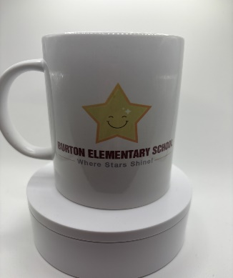
Important Dates:
April
1st | April Fool’s Day
7th | Report Cards Go Home  Razzmatazz for Kids @ 1:00PM
10th | Parent Teacher conferences in the evening  *Logo Mug orders due
11th | Parent Teacher conferences in the morning. Professional Learning for staff in the afternoon. No school for students.
15th | PSSC @ 5:30
17th | Egg Hunt
18th | Good Friday-No School
21st | Easter Monday- No School
23rd | Administrative Assistants Day- Thank you Mrs. Morabito for all you do for our school! 
24th | School Dance 6:00-7:00
May
2nd | Subject Council Day- No School
12th | NBTA Branch meeting – No School
15th | Jump Rope for Heart Event
19th | Victoria Day – No School

From the students and staff of Burton, we wish everyone a great month!

Our School Website:
https://burton.nbed.ca/

Facebook: https://www.facebook.com/profile.php?id=61564262865173

