Burton Elementary School Bulletin

February 2025 Edition

February is Black History Month
For 2025, Canada’s theme for Black History Month is: “Black Legacy and Leadership: Celebrating Canadian History and Uplifting Future Generations.” This month gives us all the chance to celebrate the diversity and achievements of Black people in Canada.
Grade 1 French Immersion
Information has been posted on the ASD-W website regarding grade one French Immersion Registration. Please visit https://asdw.nbed.ca/current-students/grades-k-12/french-immersion-registration-and-withdrawal/

Valentine’s Day
On Friday, February 14th we will celebrate Valentine’s Day with our students. Classroom teachers will be in touch with parents to inform them of various classroom events.
STARS Education for February
This month we are focusing on Kindness. Kindness is an important quality to have when growing up. When someone is kind, it means they are considerate and nice to others. Some good examples of kindness are; saying please and thank you; sharing, and doing anything that helps others. When you treat other people with kindness, both people feel good! February is kindness month.
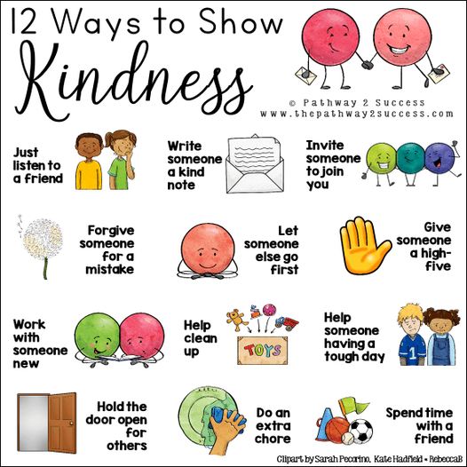

Pink Shirt Day at Burton
On Wednesday, February 26th, we are celebrating Pink Shirt Day. Students and staff are encouraged to wear pink (or white for peace) to reflect the importance of joining together in support of respect, kindness, and friendship towards one another. This day originated in Canada and the pink shirt symbolizes a stand against bullying. T-shirt order forms have been sent home and payment can be made through https://www.schoolcashonline.com/ until 11:59PM Feb 6th. Form and cash payment due by Feb 7th. No late orders can be accepted.

Skating Update
Our next skating dates are Thursday Feb 6th, Tuesday February 18th, and Thursday February 27th. Parent/family volunteers are greatly appreciated!!! During our first skating session we had amazing support from parents and grandparents. Bravo!!!

Family Day in New Brunswick
Monday, February 17th is Family Day for New Brunswick residents. Students do not attend school on this day. Have a wonderful family day everyone!

Staff Appreciation Week
Staff appreciation week will be held from February 10th-14th. Parents may wish to acknowledge the work of those who support their child at school. Thank you, Burton staff, for all you do for our students!

Parent School Support Committee
The next PSSC meeting will be held on February 18th at 5:30 PM in person. Virtually is also an option on TEAMs. All parents are welcome to attend, just let Mrs. Lowe know, so that she can add you to the invite. Everyone is welcome!
Dates to Remember:
February
2nd | Ground Hog Day
6th, 18th, 27th | Skating Days
10th – 14th | Staff Appreciation Week
13th | Rocks and Rings Curling Visit
13th | 100 Day of School
14th | Valentine’s Day
15th | Flag Day
17th | Family Day – no school
20th | Take Me Outside Day
24th-28th | Burton Spirit Week
26th | Pink Shirt Day/  Winter Carnival Day
28th | Art Richard Concert- Field trip to Geary Elementary Community School
March
3rd-7th | March Break-No School
10th | First day back after March
11th | Skating Day
12th | Field Trip to Playhouse – more info to follow

Spirit Week Feb 24-Feb 28
Monday,  Feb 24 | Tuesday,  Feb 25 | Wednesday,  Feb 26 | Thursday,  Feb 27 | Friday,  Feb 28
Hat Day!  Wear your favourite hat today!   | Wear your PJs today!   | Pink Shirt Day/Carnival Day    Skating Day   | Silly Sock Day   | Burton Stars Spirit Day  Wear your school clothing or colors (burgundy or yellow) today!

Our School Website:
https://burton.nbed.ca/

Facebook: https://www.facebook.com/profile.php?id=61564262865173



