Burton Elementary News Bulletin
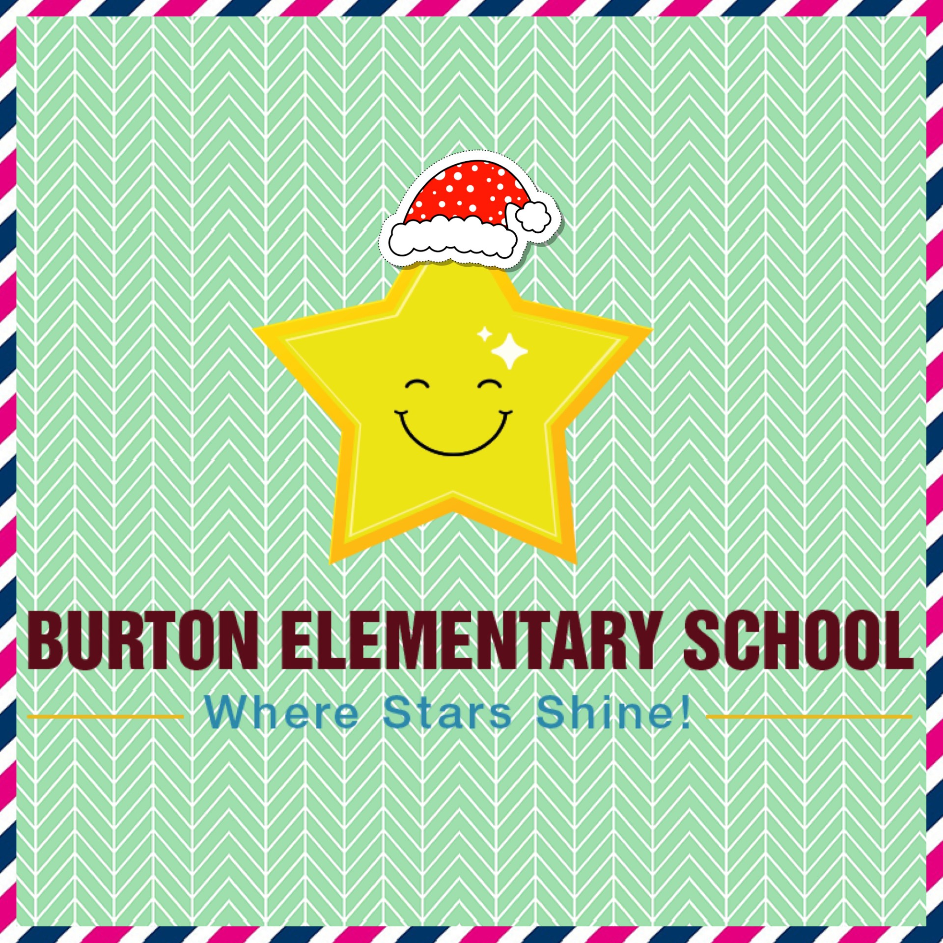
December 2024 Edition
Celebrating the Season
We invite you to join, as we celebrate the spirit of Christmas at our concert on Tuesday, December 10 at 11:00AM at the Burton Lions Club. Our talented students, under the direction of our teachers, will perform for families “The Mice Before Christmas” on this special day. If school should be closed on the 10th, the backup date is December 12th with a performance time of 11:00AM
Ticket sales have begun for our VIP concert Packages! All proceeds collected will go towards helping a BES family celebrate Christmas. A Great prize with an even greater purpose!
The draw for the VIP Concert packages will take place on Facebook Live on Dec 9th! The winners will be notified by phone call immediatly after. Good luck everyone!
Learning to Skate Feels Great!
As an extension of our Physical Education program, Burton students will have the opportunity to go skating at the Kings Arrow arena several times through the winter months. This opportunity is free of charge for our children and district school buses will provide transportation. More information and a schedule will follow. Even if your child has limited skating ability, they learn quickly at this early age. The school has a limited number of skates and helmets that can be borrowed by our students. Skates and helmets can be great Christmas gifts. Parents, grandparents, and caregivers are always welcome to join us during this time.

Burton Learning for December
Our focus is on Compassion. During this month we will be teaching and talking about caring, sharing, thinking of others, showing concern, helping others, emotional intelligence, empathy and celebrating differences.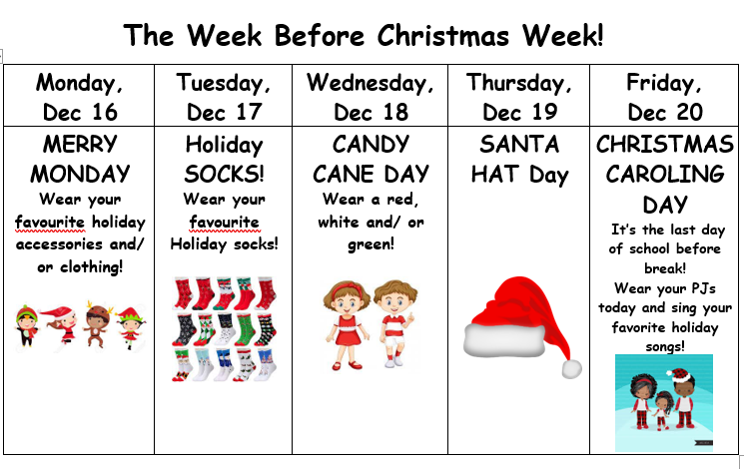

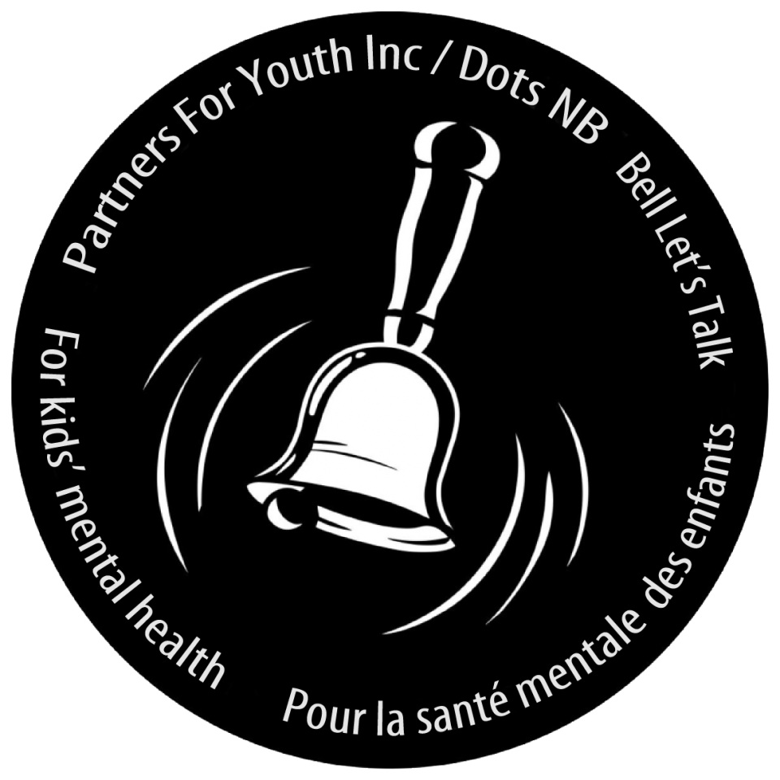
Ring A Bell Campaign
On Thursday, Dec. 5th students at Burton will be celebrating Ring a Bell Day. This day is part of a grassroots movement that has been empowering youth, family, and community to take positive actions in support of kids’ mental health.
As part of the Dots for Kids Day Ring A Bell Campaign students will revisit and continue learning about mental health and wellness in schools from Dec. 2nd-Dec 5th

**On Dec.5th just before the end of the day we will be making a noise as a whole school with the staff ringing bells to bring awareness to this campaign.
Sharing with the Oromocto Food Bank
To share the true meaning of the holiday season the Burton School community will take on a service project to help others. Recently, students participated in a poll, and they have decided that we are collecting items for the Oromocto Food Bank. Students are invited to bring in nonperishable food items until Dec 20th. For each item they bring their name will go on a ballot. Each Thursday or Friday leading up the holiday break we will draw a winner from the basket and that student will win a certificate for a Kitty Cat Pizza from Oromocto Pizza Delight! To encourage whole school participation, we will also track class contributions and the class with the highest percentage of student participation will win a Pizza Party for the whole class when they return in January! Our students love to share, and we thank Oromocto Pizza Delight for sharing with our school by donating these prizes. Bravo!

Dates to Remember
The final day for students prior to Christmas break will be Friday, December 20th.Students will return to school on
Monday, January 6th.
December
5th | Parent Teacher Interviews PM
6th | No school for students – Parent Teacher Interviews am
10th | Holiday Concert – storm day 12th
20th | Last day before Holidays
January
6th | First day back for students after Christmas break.

We wish all Burton families a peaceful, healthy, joyous holiday season and we look forward to seeing everyone in the New Year.



Our School Website:
https://burton.nbed.ca/

Facebook: https://www.facebook.com/profile.php?id=61564262865173

