Burton Elementary News Bulletin


October 2024 Edition

Zones of Regulation and our 4 School Rules
This has been our focus for the month of September. We have been revisiting and teaching recognition of emotions and how to regulate them. We have also focused on teaching/reviewing our four school rules. This month’s lessons were targeted on rule number one. Several students were recognized for showing exemplary demonstrations of this rule in our September Whole School assembly. We also started our Praise slip program where students receive a yellow slip of paper indicating that they have been “caught” demonstrating one of our school rules. All educators are happily giving these out and our students are super motivated to earn them!
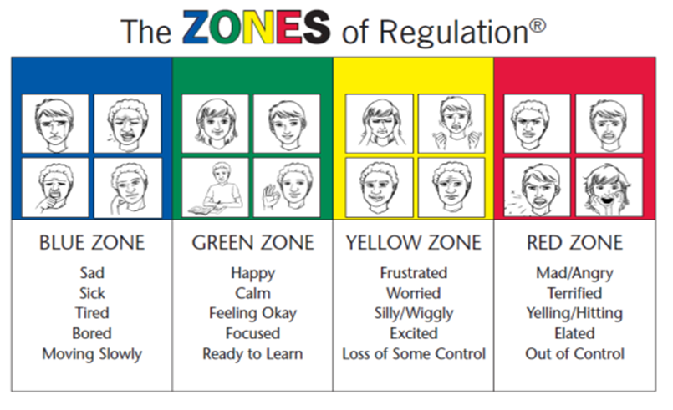
School Rules:
Rule Number 1-Be Respectful
Rule Number 2-Be Responsible
Rule Number 3- Be Safe
Rule Number 4– Be a Learner

Kindergarten Registration for 2024-2025 Registration for students entering kindergarten in September 2026 will take place at the school from Oct 15-18th during school hours. To register a child for kindergarten please register online and we will contact you to book an appointment. When you come to register, please bring:
- Proof of immunization
- Medicare card and expiry date
- Birth certificate
Feel free to pass this message along to friends and neighbours who have students starting kindergarten next fall.

Safe Schools Week
Last month we practiced several school safety routines, including fire drill, lockdown, and a whole school evacuation. This month we will review these safe school routines and include a bus safety evacuation. Each year we practice these measures so that our students are well prepared in case we need to use any of our safe school procedures. Teachers will speak with students before the events, so they are well prepared.

Fire Prevention Week
Occurs during the week of Oct 7-11th. This year’s Fire Prevention Week theme is, “Smoke Alarms, make them work for you!” This theme works to educate everyone about simple but important actions they can take to ensure their alarms are working properly and that everyone knows what to do when they hear them. We encourage all families to talk about fire safety in the home! The Oromocto Fire Station will be hosting an Open House on Oct 10th 6:00-7:30 PM. There will be activities for people of all ages.

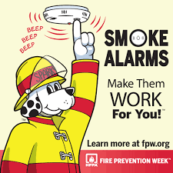

Parent School Support Committee
The first official PSSC meeting this year will be held on Oct 8th at 5:30. At this meeting we will discuss the School Improvement Plan and upcoming events. New members are always welcome to attend, and we can offer virtual options so that everyone can attend.

Home and School Volunteer News
Thank you to parents who have shown interest in helping with the Home & School Parent Volunteer group. We held our first planning meeting on Sept 16th. Our next meeting date will be this month, the date is still TBD. An email will be sent, as well as a media post made to let you know when this meeting will be held. Thank you to the parents/grandparents who have already started volunteering. Because of you we can operate our breakfast and hot lunch programs and provide unique learning opportunities for our students.
Thank you!

Hot Lunch
Hot lunch will be offered on Tuesday’s and Thursdays. The ordering process will be done through www.schoolcashonline.com and for a month at a time. Ordering will be open the first week of October. Order reminders will be sent home via email in advance to the link going live. Stay tuned for this message to arrive in your inbox!

Eyes and Ears Support our Learning
If your child has not had their vision or hearing tested recently, consider having these tested. This is an important measure that could make a huge difference in your child’s learning.

Halloween at Burton
On October 31st students are invited to wear orange and black to school as we celebrate Halloween. Teachers will contact parents about classroom activities. We do not bring costumes to school.

Say Cheese!
Burton’s picture day will be October 24th!


At a Glance Calendar

October
8th | Apple Picking Field Trip
10 | World Mental Health Day
14 | Thanksgiving – no school
15-18 | Kindergarten Registration
24 | Picture Day
31 | Halloween Activities-wear orange and black
November
8 | School Plan Day-no school
11 | Remembrance Day- no school
22 | PL Day – no school
Our School Website:
https://burton.nbed.ca/
Facebook: https://www.facebook.com/profile.php?id=61564262865173

